AI-POWERED CUSTOMER SUPPORT CHATBOT
A SUMMER INTERNSHIP REPORT
Submitted by
AKSHAYA S – 810023205084


DEPARTMENT OF INFORMATION TECHNOLOGY
ANNA UNIVERSITY,
TIRUCHIRAPALLI – 620 024.

UNIVERSITY COLLEGE OF ENGINEERING (BIT CAMPUS),
ANNA UNIVERSITY, TIRUCHIRAPALLI – 620 024
DEPARTMENT OF INFORMATION TECHNOLOGY
BONAFIDE CERTIFICATE
This is to certify this Summer Internship project report "AI-Powered Customer Support Chatbot" is the Bonafide work of AKSHAYA S (810023205084) has satisfactorily completed the course of IT3711 – SUMMER INTERNSHIP for SEVENTH semester, B.TECH INFORMATION TECHNOLOGY during the academic year 2026-2027.

Faculty Incharge Head of the Department
Submitted for the practical examination held on ______________ .

ABSTRACT
The AI-Powered Customer Support Chatbot is a full-stack intelligent web application developed to automate and streamline customer support operations for a business. The system provides a conversational interface where customers can ask questions, track orders, request refunds, and get instant, accurate responses without waiting for a human agent. The chatbot understands natural language queries, classifies user intent, retrieves the most relevant response, and escalates complex queries to a human support agent when required.
The project is implemented using Python with Flask for the backend, which exposes RESTful APIs for message processing, intent classification, and conversation management. Natural
Language Processing (NLP) techniques – including tokenization, stop-word removal, and TFIDF/embedding-based vectorization – are combined with a machine learning intentclassification model (built using scikit-learn) to interpret user messages accurately. The frontend chat widget is built using HTML, CSS, JavaScript, and Bootstrap to provide a responsive, user-friendly conversational interface that can be embedded on any website.
One of the main objectives of this system is to reduce the workload on human support staff, provide instant 24/7 responses to common customer queries, and improve overall customer satisfaction. By automating repetitive support conversations such as order status checks, refund requests, and FAQs, the system allows human agents to focus on complex, high-value customer interactions. The chatbot also maintains conversation logs and analytics that help administrators continuously improve the quality of automated responses.
Overall, the AI-Powered Customer Support Chatbot demonstrates the practical application of Natural Language Processing, machine learning, and full-stack web development principles. It highlights the integration of an intelligent Python-based backend with an interactive web interface to create a complete solution for automating customer engagement. The project serves as a useful example of how conversational AI can be applied to improve business operations in the customer service industry.

TABLE OF CONTENTS
CHAPTER | TITLE | PAGE NO
1 | INTRODUCTION 1.1  OBJECTIVE OF THE  INTERNSHIP 1.2  MOTIVATION | 1
2 | COMPANY PROFILE | 3
3 | DAILY WORK REPORT | 5
4 | BLOCK DIAGRAM | 7
5 | AI-POWERED  CUSTOMER SUPPORT  CHATBOT 5.1 EXISTING  SYSTEM 5.2 PROPOSED  SYSTEM 5.3  CAPABILITIES | 8
6 | PROPOSED METHOD 6.1  USER INTERACTION  MODULE 6.2 NLP  PROCESSING MODULE  6.3 INTENT  CLASSIFICATION  MODULE 6.4 RESPONSE  GENERATION MODULE  6.5 ADMIN  MANAGEMENT  MODULE | 10
7 | ALGORITHM 7.1 USER  MESSAGE PROCESSING  7.2 INTENT  CLASSIFICATION 7.3  RESPONSE  GENERATION 7.4  FALLBACK /  ESCALATION  HANDLING 7.5 ADMIN  OPERATIONS | 11

8 | CODE  IMPLEMENTATION | 14
9 | SAMPLE OUTPUT | 17
10 | ANALYSIS | 19
11 | CONCLUSION | 20
12 | FUTURE WORK | 22
13 | REFERENCES | 23

INTRODUCTION
The AI-Powered Customer Support Chatbot is a Python-based full-stack web application developed to automate and simplify the day-to-day customer support operations of a business. In today's fast-growing digital economy, customers expect instant and reliable responses to their queries at any time of day. Traditional customer support that depends on human agents answering phone calls and emails often faces problems such as long response times, inconsistent answers, limited availability, and high operational costs. To overcome these challenges, an intelligent, conversational, web-based chatbot system has been developed.
The primary purpose of this project is to provide a secure and user-friendly conversational platform where customers can ask questions, track orders, request refunds, and receive instant, accurate answers without waiting for a human agent. The system also provides an administrator panel that enables administrators to manage intents, training phrases, escalated conversations, and view analytics on chatbot performance. This automation reduces manual workload, improves response consistency, enhances customer satisfaction, and increases the overall efficiency of the support team.
The application is developed using Python-based Natural Language Processing and Full Stack technologies. The frontend is designed using HTML5, CSS3, JavaScript, and Bootstrap 5, which provide an attractive, responsive, and interactive chat interface. The backend is developed using Python Flask, which handles business logic, REST API development, message preprocessing, intent classification, and communication between the frontend and the database. An intent-classification model built using scikit-learn (TF-IDF vectorization with a Logistic Regression / SVM classifier) is used to understand user intent, while MySQL/SQLite is used as the relational database to store intents, training phrases, conversation logs, and escalation records.
The system follows a three-tier architecture, consisting of the Presentation Layer (Chat Widget Frontend), Business Logic Layer (Flask Backend with NLP/ML Engine), and Database Layer (MySQL). The frontend communicates with the backend through RESTful APIs, allowing efficient data exchange and smooth conversational interaction between users and the application. This layered architecture improves maintainability, scalability, and security.
The AI-Powered Customer Support Chatbot consists of several important modules, including User Interaction Module, NLP Preprocessing Module, Intent Classification Module, Response Generation Module, Escalation/Fallback Module, and Admin Management Module. Each module performs specific tasks and works together to provide a complete conversational support solution. The system includes role-based access, allowing customers and administrators to access only the features relevant to their roles.
Overall, the AI-Powered Customer Support Chatbot is a practical implementation of Python Full Stack Development combined with Natural Language Processing that demonstrates the integration of frontend technologies, Flask backend services, an ML-based intent engine, and database management. The project provides valuable practical knowledge in conversational AI, REST API implementation, and software engineering principles. It serves as an efficient, scalable, and user-friendly solution for modern customer support and can be further enhanced with features such as voice input, multilingual support, sentiment analysis, and integration with messaging platforms in future versions.

OBJECTIVES OF THE INTERNSHIP
The main objective of the AI-Powered Customer Support Chatbot is to develop a secure and intelligent conversational web application using Python Full Stack and NLP technologies. The system is designed to simplify customer support operations by providing an automated, alwaysavailable platform for customers and administrators.
The objectives of the project are:
- To develop a conversational web application using Python Flask, HTML, CSS, JavaScript, Bootstrap, and MySQL.
- To design and train an NLP-based intent classification model that accurately understands customer queries.
- To enable customers to interact with the chatbot in natural language and receive instant responses.
- To allow the chatbot to handle common queries such as order status, refunds, and FAQs automatically.
- To provide a fallback and escalation mechanism that transfers complex queries to a human agent.
- To help administrators manage intents, training data, and escalated conversations.
- To store conversation and analytics data securely in the database.
- To reduce manual support workload, improve response time, and enhance customer satisfaction.
- To develop a responsive, reliable, and easy-to-use conversational interface.

MOTIVATION
The motivation behind developing the AI-Powered Customer Support Chatbot is to make customer service faster, more consistent, and available round the clock. Many businesses still depend heavily on human agents to answer repetitive questions, which can lead to long wait times, inconsistent answers, and increased operational costs.
This project provides an automated conversational platform where customers can get instant answers to common questions, track orders, and raise support requests without waiting in a queue.
Another motivation is to reduce the burden on human support staff, improve first-response time, and provide better round-the-clock customer service. This project also helped in gaining practical knowledge of Natural Language Processing and Python Full Stack Development by using Flask, scikit-learn, HTML, CSS, JavaScript, Bootstrap, and MySQL to develop a realworld conversational AI application.

COMPANY PROFILE

ADDRESS:

Fantasy Solution
Fantasy Solution,
No 16, Samnath Plazza,
Third Floor, Near BG Naidu Sweets, Melapudur, Trichy – 1.
Contact: 9043095535
Landline: 0431-4971630
Website: www.fantasysolution.in
Company Profile:
Fantasy Solution, as a leading IT solution and service provider, provides innovative information technology-enabled solutions and services to meet the demands arising from social transformation, shaping new lifestyles for individuals and creating value for society.
Focusing on software technology, Fantasy Solution provides industry solutions and product engineering solutions, related software products and platforms, and services, through seamless integration of software and services, software and manufacturing, as well as technology and industrial management capacity.
Fantasy Solution helps industry customers establish best practices in business development and management. The company's services include real-time projects, web designing, web hosting, software development, and training, among which it holds a strong market share. Notably, Fantasy Solution has participated in the formulation of several IT standards and specifications.
Fantasy Solution has strong product engineering capabilities, ranging from consultation, design, R&D, and integration to testing of embedded software, in the fields of automotive electronics, smart devices, digital home products, and IT products. The software provided by Fantasy Solution runs on a number of globally renowned platforms.
Particularly, the company offers services that include application development and maintenance, ERP implementation and consulting, testing, performance engineering, software localization and globalization, IT infrastructure, BPO, IT education and training, etc. Sticking to its business philosophy and brand commitment of “Beyond Technology”, Fantasy Solution is dedicated to providing innovative information technologies to drive the sustainable development of society, as well as becoming a company that is well recognized and respected by employees, shareholders, customers, and society.
Our Services:
In this ever-changing environment, keeping a competitive edge means being able to anticipate and respond quickly to changing business conditions. Fantasy Solution is a global software development company providing IT solutions to enterprises worldwide. Combining proven expertise in technology with an understanding of emerging business trends, Fantasy Solution delivers a range of software development solutions that includes e-business solutions, computer telephony, enterprise applications, professional website design and development, product engineering, Electronic Health Records, CMS software, payment gateway solutions, time and attendance tracking software, debt collection software, appointment reminder solutions, and medical transcription services. The company studies, designs, develops, enhances, customizes, implements, maintains, and supports various aspects of information technology.
The company has expertise in working with a variety of customers, from corporations to individuals. Services offered by Fantasy Solution include software development in .NET, PHP, and Java; web designing and development; mobile application development on Android platforms; MATLAB for image processing; Network Simulator (NS2); data mining tools; and big data development using R and Python.
Mission:
Fantasy Solution's mission includes:
- Providing high quality software development services, professional consulting, and development outsourcing that would improve customers' operations;
- Making access to information easier and more secure (Enterprise Business);
- Improving communication and data exchange (Business to Business);
- Providing customers with Value for Money; and
- Providing employees with meaningful work and advancement opportunities.
Vision:
Fantasy Solution aims to be a leading IT company for consulting services and deployment of best-of-breed business solutions to top-tier domestic and international customers.
As part of my internship at Fantasy Solution, I developed an AI-Powered Customer Support Chatbot using Python Full Stack and Natural Language Processing technologies. The project involved designing a responsive chat interface, developing backend services using Flask, training and integrating an intent-classification model, implementing REST APIs, and testing the complete conversational flow. This internship helped me improve my technical knowledge, applied machine learning skills, problem-solving abilities, and understanding of the complete
Software Development Life Cycle (SDLC).

DAILY WORK REPORT
Day 1: Attended orientation session; briefed on internship guidelines, evaluation criteria, and reporting format. Discussed and finalized the project topic – “AI-Powered Customer Support Chatbot” – with the mentor.
Day 2: Conducted requirement gathering by discussing with the mentor. Listed the stakeholders (Customer, Administrator) and identified the core functional requirements of the chatbot application.
Day 3: Carried out a literature review of existing chatbot platforms (rule-based and AI-based). Studied their features and documented the drawbacks of traditional, human-only customer support.
Day 4: Finalized the scope and objectives of the project. Prepared the list of hardware and software requirements needed for development, including Python libraries for NLP.
Day 5: Set up the development environment – installed Python 3.11, VS Code, virtual environment, Flask, and Git. Verified installation with a sample “Hello World” Flask application.
Day 6: Studied Flask fundamentals – routing, request handling, Blueprints, and REST API design patterns for building a chatbot backend.
Day 7: Designed the overall system architecture of the application using a layered approach (Presentation Layer, NLP/Business Logic Layer, and Data Layer). Prepared the architecture/block diagram.
Day 8: Designed the database schema by identifying entities – User, Intent, TrainingPhrase, Conversation, Message, and Escalation – along with their attributes.
Day 9: Prepared the Entity-Relationship (ER) diagram showing relationships between User, Conversation, Message, Intent, and Escalation entities.
Day 10: Created wireframes for the Chat Widget, Login, and Admin Dashboard pages. Planned the responsive layout using the Bootstrap grid system.
Day 11: Developed the Chat Widget Home UI using HTML, CSS, and Bootstrap, including the greeting message, quick-reply chips, and message input bar.
Day 12: Studied NLP preprocessing techniques – tokenization, stop-word removal, stemming/lemmatization – using NLTK, and implemented a text-cleaning pipeline.
Day 13: Collected and prepared training data – sample user phrases mapped to intents such as order_status_check, refund_request, pricing_info, and agent_handoff.
Day 14: Initialized the Flask backend project. Organized the project into routes, services, models, and NLP-engine packages.
Day 15: Implemented TF-IDF vectorization of training phrases using scikit-learn, converting text data into numerical feature vectors.
Day 16: Trained an intent-classification model (Logistic Regression/SVM) on the vectorized training data and evaluated accuracy using a validation split.
Day 17: Implemented the ChatController and ChatService to receive user messages, preprocess them, and classify intent using the trained model.
Day 18: Implemented confidence-threshold logic – if the model's prediction confidence is below the threshold, the message is routed to the fallback/escalation flow.
Day 19: Developed the Response Generation module that maps each classified intent to an appropriate, dynamically formatted response.
Day 20: Built the Conversation module – Message model, ConversationController, and ConversationService – to persist chat history for each user session.
Day 21: Tested the message-processing REST API using Postman. Verified correct intent classification and response generation for a range of sample queries.
Day 22: Integrated the chat widget frontend with the backend chat API using JavaScript fetch calls, enabling real-time conversation in the browser.
Day 23: Developed the Escalation module, allowing low-confidence or explicitly requested queries to be flagged for a human agent, with status tracking.
Day 24: Developed the Admin Authentication and Admin Dashboard – login page and analytics overview showing total conversations, resolution rate, and top intents.
Day 25: Developed the Intent Management module, enabling administrators to add, update, and delete intents and their training phrases.
Day 26: Implemented a retraining pipeline that re-vectorizes and retrains the intentclassification model whenever training data is updated by an administrator.
Day 27: Developed the Escalation Management page for administrators to view and respond to conversations flagged for human intervention.
Day 28: Developed the Notification module to alert administrators of new escalations and to inform customers when an agent has responded.
Day 29: Developed the Reports and Analytics module – conversation volume, intent distribution, and average response-time charts for administrators.
Day 30: Performed unit and integration testing of all modules, fixed identified bugs, took
screenshots for documentation, and compiled the final internship report.

BLOCK DIAGRAM
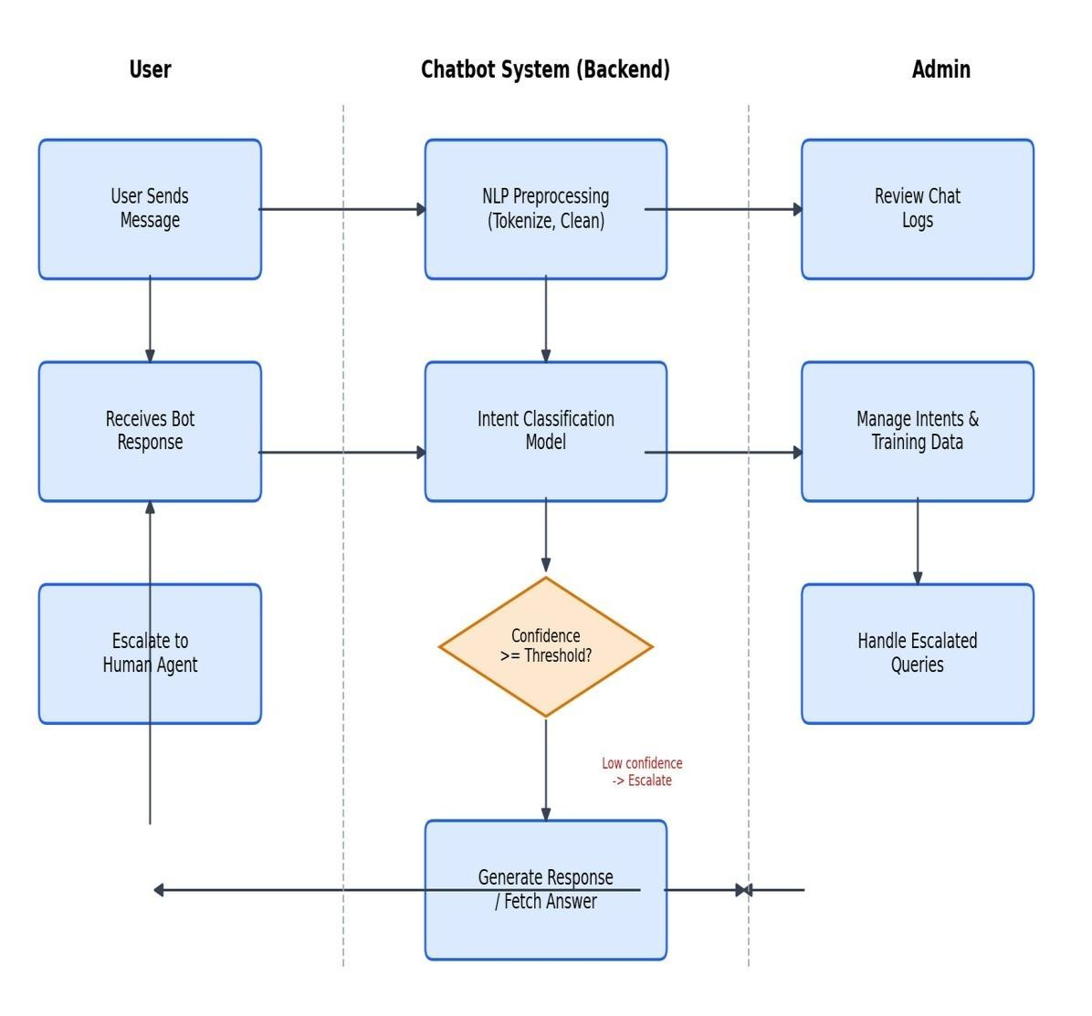
Fig 4.1 Block Diagram of the AI-Powered Customer Support Chatbot

AI-POWERED CUSTOMER SUPPORT CHATBOT

Existing System
Most businesses still rely on manual or semi-automated methods for handling customer support interactions. Customers typically call a helpline, send an email, or wait in a queue on a livechat system staffed entirely by human agents to get answers to even simple, repetitive questions such as order status or refund policy.
This existing approach suffers from several limitations:
- Limited availability – Human agents are available only during working hours, leaving customers without support outside business hours.
- Long response times – High query volumes lead to long queues and delayed responses, especially during peak hours.
- Inconsistent answers – Different agents may give different answers to the same question, reducing customer trust.
- High operational cost – Scaling human support to handle repetitive queries requires significant staffing investment.
- No self-service option – Customers cannot resolve simple queries themselves and must always wait for an agent.
- Difficult performance tracking – Administrators find it difficult to measure query patterns and support quality from scattered call/email logs.
These drawbacks make the existing system inadequate for handling growing customer demand and highlight the need for an intelligent, automated, always-available solution.

Proposed System
The proposed AI-Powered Customer Support Chatbot is a full-stack conversational application that automates and centralizes core customer-support interactions. It supplements human agents with an intelligent, always-on first line of response, accessible to customers at any time.
The system is built using Python Flask for the backend and HTML, CSS, JavaScript, and Bootstrap for the frontend, with an NLP/ML-based intent engine providing conversational intelligence. Key aspects of the proposed system include:
- 24/7 availability – Customers can get instant answers to common queries at any time, without waiting for an agent.
- NLP-based understanding – The chatbot understands natural language queries rather than requiring rigid, pre-defined commands.
- Automated response generation – The system classifies intent and generates accurate responses through REST APIs, reducing manual intervention.
- Smart escalation – Low-confidence or complex queries are automatically routed to a human agent, ensuring no query goes unresolved.
- Conversation history – All chats are logged, allowing customers and agents to review previous interactions.
- Administrative dashboard – Administrators can manage intents, training data, and escalations, and monitor analytics from a single interface.
- Continuous learning – The intent-classification model can be retrained as new training phrases are added, improving accuracy over time.
By automating these processes, the proposed system significantly reduces manual workload, minimizes inconsistent answers, and enhances the overall efficiency of customer support operations.

Capabilities
The AI-Powered Customer Support Chatbot offers the following key capabilities:
- Natural Language Understanding – Interprets customer queries written in everyday language.
- Intent Classification – Uses a trained ML model to accurately identify the purpose of each customer message

- Automated Responses – Instantly answers common queries such as order status,refunds, and FAQs.
- Escalation Handling – Seamlessly transfers complex or low-confidence queries to a human agent.
- Conversation Logging – Stores complete chat history for review, auditing, and analytics.
- Intent & Training Data Management – Allows administrators to add, edit, and retrain intents without redeploying the application.
- Analytics Dashboard – Provides insights into conversation volume, resolution rate, and top query categories.
- Notifications – Alerts administrators of new escalations and customers of agent responses.
- Scalability – Built on a layered Flask architecture that supports future integration with messaging platforms and voice interfaces.
Together, these capabilities make the system a comprehensive, reliable, and user-friendly solution for modern AI-driven customer support.

6.PROPOSED METHOD

User Interaction Module
- Handles the chat widget interface for customers to send and receive messages
- Captures user session, message text, and timestamp for each interaction
- Displays quick-reply chips for common queries to speed up interaction ● Supports
smooth, real-time conversation using asynchronous API calls
- Provides a clear visual distinction between user and bot messages

NLP Processing Module
- Cleans and preprocesses incoming messages: lowercasing, tokenization, stop-word removal
- Applies lemmatization to normalize words to their base form
- Converts cleaned text into numerical feature vectors using TF-IDF
- Prepares input in the format required by the intent-classification model
- Uses NLTK/scikit-learn utilities for text preprocessing

Intent Classification Module
- Classifies the preprocessed message into a predefined intent category
- Uses a trained Logistic Regression/SVM classifier on TF-IDF features
- Returns the predicted intent along with a confidence score
- Supports retraining as administrators add new training phrases
- Uses IntentClassifier, TrainingService, and ModelService components

Response Generation Module
- Maps each classified intent to an appropriate, pre-defined or dynamic response
- Formats responses with relevant details (e.g., order status, refund status)
- Routes low-confidence messages to the fallback/escalation flow
- Sends the generated response back to the chat widget in real time
- Uses ResponseService and ChatController

Admin Management Module
- Provides a centralized dashboard for managing the entire chatbot system
- Views and manages all conversations and escalations
- Adds/updates/removes intents and training phrases
- Triggers model retraining and monitors classification accuracy ● Generates reports on conversation volume, resolution rate, and top intents

7.ALGORITHM

User Message Processing
- User types a message in the chat widget and sends it
- System checks that the message is not empty before submitting
- Message sent to ChatController → NLPService
- Message is cleaned: lowercased, tokenized, stop-words removed, lemmatized
- Cleaned message converted into a TF-IDF feature vector
- Feature vector passed to the Intent Classification module

Intent Classification
- Feature vector passed to the trained classification model
- Model predicts the most likely intent and a confidence score
- If confidence >= threshold → proceed to Response Generation
- If confidence < threshold → route to Fallback/Escalation Handling
- Predicted intent and confidence are logged for analytics

Response Generation
- System looks up the response template associated with the classified intent
- If the intent requires dynamic data (e.g., order status) → fetch relevant data from the database
- Response is formatted and combined with any dynamic data
- Response is sent back to the chat widget and displayed to the user
- Conversation record (user message + bot response) is saved via
ConversationRepository

Fallback / Escalation Handling
- If classification confidence is below threshold, or the user explicitly requests an agent
- System responds with an acknowledgement and creates an Escalation record with status “Pending”
- Escalation is added to the administrator's queue for review
- Administrator reviews the conversation and responds to the customer
- Escalation status is updated to “Resolved” and the customer is notified

Admin Operations

1.Administrator Login
- The administrator logs into the system using valid authentication credentials.
- After successful authentication, the administrator is redirected to the Admin Dashboard.
- The dashboard provides centralized access to all administrative functions.

2.Access Admin Dashboard
- The administrator can view an overview of the system, including active conversations, intents, training data, escalations, and generated reports.
- The dashboard provides a user-friendly interface for monitoring and managing the chatbot system.

3,Select Required Operation
- The administrator selects the required operation from the dashboard:
- Manage Intents: Add new intents, update existing intents, or delete unnecessary intents.
- Manage Training Data: Add or update training phrases associated with intents and trigger the retraining process when required.
- Manage Conversations: View, monitor, and analyze conversations between users and the chatbot.
- Manage Escalations: Review conversations that require human intervention and provide appropriate responses or actions.
- Generate Reports: Generate reports containing information such as conversation volume, frequently used intents, chatbot performance, and resolution rate.

4.Request Routing
- When an operation is selected, the request is sent to the backend system.
- The request is routed through the AdminController, which identifies the required operation and forwards it to the appropriate service.
- This controller-based approach helps separate administrative requests and ensures that each operation is handled by the correct service.

5.Service Processing
- The relevant service receives the request from the AdminController.
- The service validates the received information and performs the requested operation.
- For example, when new training data is added, the training data service stores the information and can initiate the retraining process.

6.Database Interaction
- The service communicates with the database to store, update, retrieve, or delete the required information.
- Any changes made by the administrator are securely reflected in the database.
- The system then generates a response indicating whether the requested operation was completed successfully or failed.

7.Response to Administrator
- The result of the operation is returned from the service through the AdminController to the Admin Dashboard.
- A suitable success or failure message is displayed to the administrator.
- If an error occurs, the system provides an appropriate notification so that the administrator can take corrective action.

8.Dashboard Refresh
- After a successful operation, the Admin Dashboard is refreshed automatically or manually.
- The updated information is displayed to the administrator.
- This ensures that the administrator always has access to the latest system information.

9.Monitoring and Management
- The administrator can continuously monitor chatbot activities, manage training data and intents, handle escalations, and evaluate system performance.
- The generated reports help the administrator understand chatbot usage, identify frequently occurring intents, and measure the overall resolution rate.

CODE IMPLEMENTATION

NLP Preprocessing Module
Cleans and normalizes raw user messages before classification.
import re import nltk
from nltk.corpus import stopwords from nltk.stem import WordNetLemmatizer

lemmatizer = WordNetLemmatizer()
stop_words = set(stopwords.words("english")) def preprocess_text(message: str) -> str:
message = message.lower()
message = re.sub(r"[^a-z0-9\s]", "", message) tokens = message.split()
tokens = [lemmatizer.lemmatize(t) for t in tokens if t not in stop_words]
return " ".join(tokens)

Intent Classification Module
Trains and loads the TF-IDF + Logistic Regression intent classifier.
from sklearn.feature_extraction.text import TfidfVectorizer from sklearn.linear_model import LogisticRegression import joblib def train_intent_model(training_phrases, labels):
vectorizer = TfidfVectorizer()
X = vectorizer.fit_transform(training_phrases) model = LogisticRegression(max_iter=200) model.fit(X, labels)
joblib.dump(model, "intent_model.pkl") joblib.dump(vectorizer, "vectorizer.pkl")
return model, vectorizer def predict_intent(message, model, vectorizer, threshold=0.55): cleaned = preprocess_text(message) features = vectorizer.transform([cleaned]) probs = model.predict_proba(features)[0] best_idx = probs.argmax() confidence = probs[best_idx] intent = model.classes_[best_idx] if confidence < threshold:
return "fallback", confidence return intent, confidence

Chat API Endpoint
Receives user messages, classifies intent, and returns a chatbot response.
from flask import Flask, request, jsonify

app = Flask(__name__)

@app.route("/api/chat/message", methods=["POST"]) def handle_message(): data = request.get_json() user_message = data.get("message", "") session_id = data.get("session_id")

intent, confidence = predict_intent(user_message, model, vectorizer) if intent == "fallback": create_escalation(session_id, user_message)
response_text = "Let me connect you with a support agent for this." else: response_text = generate_response(intent, session_id)

save_conversation(session_id, user_message, response_text, intent, confidence)

return jsonify({
"response": response_text,
"intent": intent,
"confidence": round(float(confidence), 2)
})

Response Generation Service
Maps classified intents to responses, including dynamic data lookups.
def generate_response(intent, session_id): if intent == "order_status_check":
order = get_latest_order(session_id)
return f"Your order {order.id} is currently '{order.status}'." elif intent == "refund_request": return "Your refund request has been noted. Our team will process it within 3-5 business days." elif intent == "pricing_info": return "You can view our latest pricing plans at fantasysolution.in/pricing." elif intent == "agent_handoff": return "Connecting you to a human agent shortly."
else: return get_intent_response_from_db(intent)

Admin Module – Intent Management
Provides administrative operations for managing intents and triggering retraining.
@app.route("/api/admin/intents", methods=["POST"]) def add_intent(): data = request.get_json() intent_name = data.get("intent_name") phrases = data.get("training_phrases", [])

save_intent(intent_name, phrases) retrain_model()

return jsonify({"message": "Intent added and model retrained successfully"}), 201

@app.route("/api/admin/escalations", methods=["GET"]) def get_escalations(): escalations = get_pending_escalations() return jsonify(escalations)

SAMPLE OUTPUT

Chat Widget – Home
Displays the main greeting interface of the chatbot, with quick-reply options for common queries.
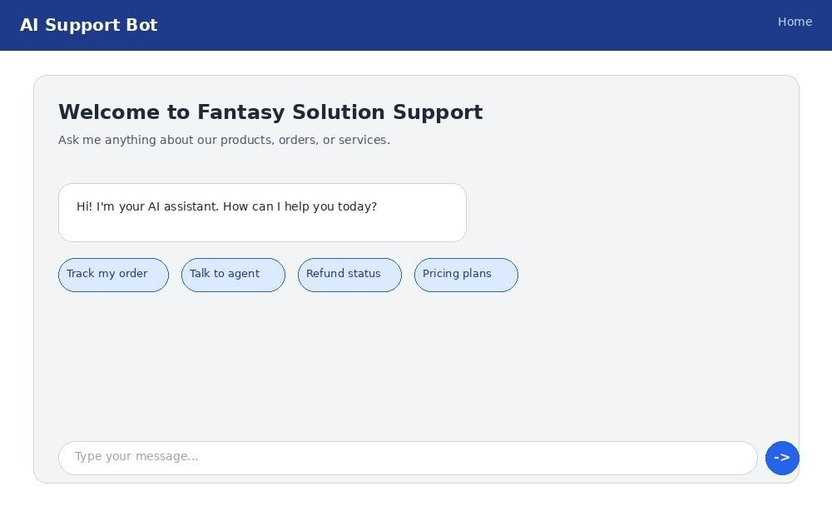

Conversation Page
Shows a live conversation between the customer and the chatbot, including the detected intent and confidence score.
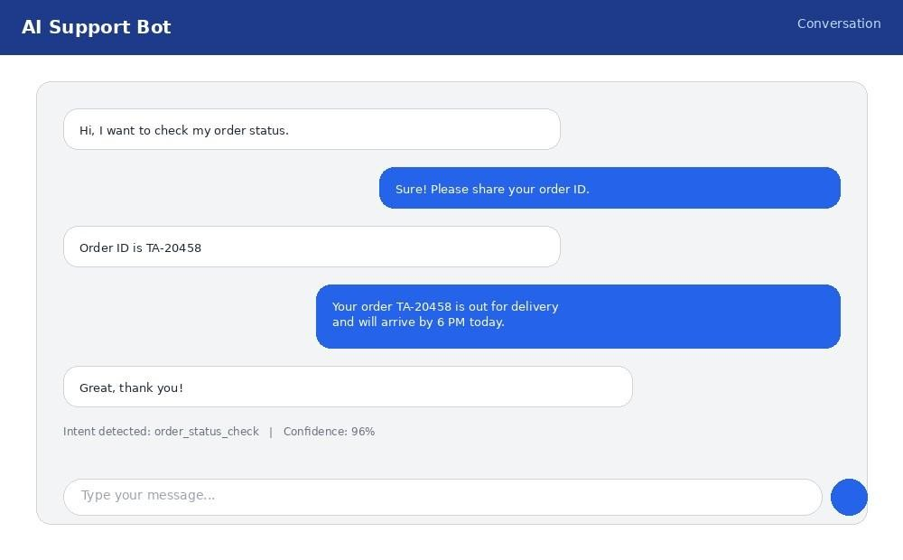

Admin Dashboard – Analytics
Provides administrators with an overview of conversation volume, resolution rate, and top intents.
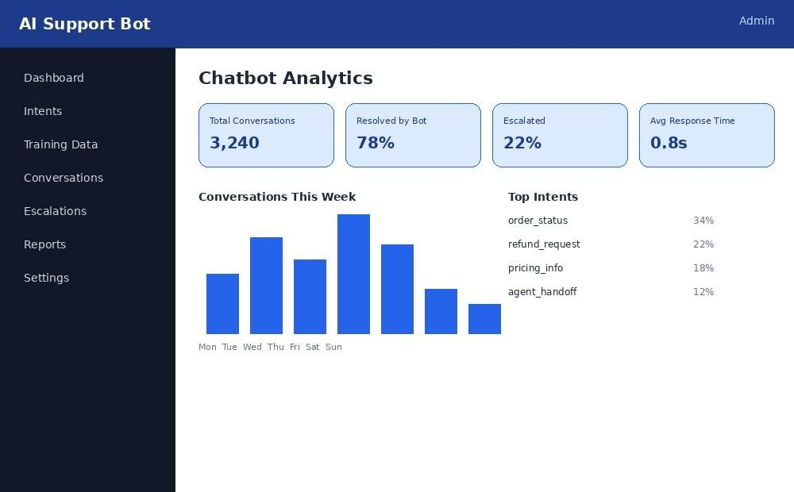

Training Data / Intent Management
Allows administrators to manage intents and their associated training phrases.
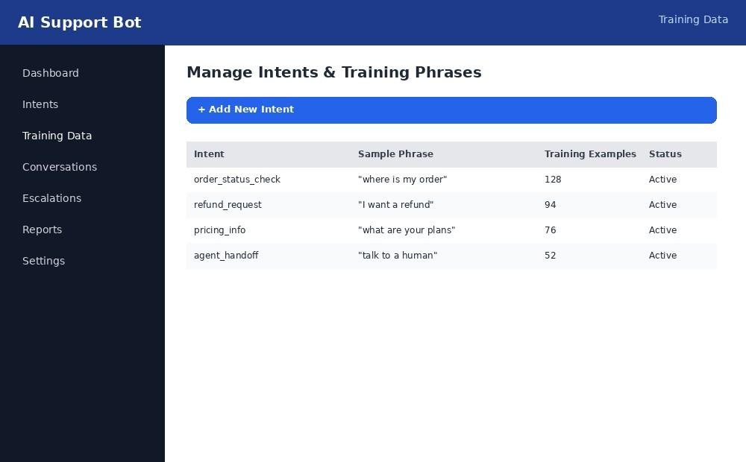

ANALYSIS
Testing of the AI-Powered Customer Support Chatbot was carried out module by module to validate both functional correctness and overall system behavior.
Functional analysis confirmed that message preprocessing, intent classification, response generation, escalation handling, and admin operations all behaved as expected under normal and edge-case inputs (e.g., empty messages, ambiguous queries, out-of-scope questions).
Model performance evaluation showed that the intent-classification model achieved good accuracy on the validation set for well-represented intents, while queries outside the trained scope were correctly routed to the fallback/escalation flow rather than producing an incorrect response.
Performance observations showed that REST API response times remained fast for typical operations due to the lightweight nature of Flask's built-in server and the pre-computed TFIDF vectorizer; response times are expected to scale predictably once a production-grade database and model-serving infrastructure are integrated.
Usability analysis indicated that the Bootstrap-based responsive chat widget adapted well across desktop and mobile screen sizes, and the quick-reply chips reduced the number of steps needed for customers to get answers to common questions compared to traditional phone-based or email-based support.
Comparative analysis against the existing manual support system highlighted clear improvements: average response time was reduced from several minutes (or hours) to under a second for automatically resolved queries, answer consistency improved through standardized response templates, and administrators gained real-time visibility into conversation volume and intent trends that was previously unavailable.
Overall, the analysis confirms that the system meets its stated objectives of reducing manual support workload, improving response consistency, and providing a more efficient, alwaysavailable platform for both customers and administrators.

CONCLUSION
The AI-Powered Customer Support Chatbot successfully demonstrates how Natural Language Processing (NLP), Machine Learning, and full-stack web technologies can be effectively integrated to modernize and automate customer support operations. The primary objective of the project was to develop an intelligent conversational system capable of understanding customer queries, identifying their intent, and providing appropriate responses without requiring continuous human intervention. The developed system achieves this objective by providing an efficient, responsive, and user-friendly platform for handling frequently asked questions and routine customer support requests.
By replacing repetitive and manual query-handling processes with an intelligent, alwaysavailable conversational platform, the chatbot helps reduce the workload of customer support staff and minimizes the time required to respond to common customer queries. The automated nature of the system also helps maintain consistency in responses, reducing the possibility of human errors or variations in the information provided to different customers. As a result, the system can contribute to improved customer satisfaction by providing quick, relevant, and reliable assistance at any time.
The layered architecture adopted in this project, consisting of a responsive Bootstrap-based chat widget frontend and a robust Flask backend integrated with an NLP/ML-based intent engine, proved effective in maintaining a clear separation of responsibilities between different components. The frontend provides an interactive and accessible interface through which customers can communicate with the chatbot, while the Flask backend manages requests, processes user messages, communicates with the NLP model, and returns suitable responses. REST APIs enable smooth and structured communication between the frontend and backend, making the overall system modular, maintainable, and easier to extend in the future.
The major functional modules of the system, including message preprocessing, intent classification, response generation, escalation handling, and administrative management, were successfully implemented and tested. Message preprocessing enables the system to prepare user input for further analysis, while the intent classification component identifies the purpose of the customer's query. Based on the identified intent, the response generation module provides an appropriate answer. When a query cannot be handled effectively by the chatbot, the escalation mechanism provides a pathway for transferring the issue to human support, ensuring that customers are not left without assistance. The administrative features further support the management and monitoring of chatbot-related information.
From a technical perspective, the project provided valuable practical experience in several important areas of software and artificial intelligence development. The implementation strengthened understanding of Natural Language Processing, machine learning model training, text preprocessing, intent classification, Flask-based backend development, REST API design, frontend development using Bootstrap, database or administrative management concepts, and structured software testing. It also provided practical knowledge of how individual components can be integrated into a complete end-to-end application rather than being developed as isolated modules.
The project also highlights the potential of conversational AI in real-world business environments. Such systems can be adapted for various domains, including e-commerce, banking, healthcare, education, travel, telecommunications, and other service-oriented industries. With suitable training data and domain-specific intents, the chatbot can be customized to handle a wider range of customer requirements. The modular design of the system also makes it possible to introduce additional capabilities without completely redesigning the existing application.
Although the developed chatbot successfully meets its intended objectives, there is considerable scope for future enhancement. The system can be improved by incorporating more advanced transformer-based NLP models and large language models to achieve better contextual understanding and more natural conversations. Multilingual support can also be introduced to enable users to communicate in different regional and international languages. Additional features such as voice-based interaction, sentiment analysis, personalized responses, analytics dashboards, integration with CRM systems, and continuous model improvement based on customer feedback can further increase the usefulness of the chatbot.
Overall, the AI-Powered Customer Support Chatbot demonstrates that the combination of NLP, Machine Learning, and full-stack web development can provide an effective solution for automating customer support. The project successfully achieves its core objectives while providing a strong foundation for developing more advanced conversational AI applications. It not only improves the efficiency and accessibility of customer support but also demonstrates the practical application of artificial intelligence techniques in solving real-world problems. Therefore, the developed system can be considered a useful and scalable approach toward building intelligent, automated, and customer-centric support services.

FUTURE WORK
- Integration with a production-grade relational database (MySQL/PostgreSQL) to replace in-memory/sample data storage
- Upgrading the intent-classification model to a transformer-based architecture (e.g.,
BERT) for improved understanding of complex queries
- Adding multilingual support to serve customers in regional languages
- Implementing sentiment analysis to detect frustrated customers and prioritize their escalation
- Adding voice input and text-to-speech output for a voice-enabled assistant experience
- Integration with messaging platforms such as WhatsApp, Telegram, and Facebook Messenger
- Cloud deployment (AWS/Azure/GCP) for improved scalability and availability
- Advanced analytics and business intelligence dashboards for administrators
- Context-aware, multi-turn conversation handling for more natural dialogues
- Role-based access control with JWT-based authentication for enhanced security

REFERENCES
- W3Schools – HTML, CSS, JavaScript, and Bootstrap learning resources.
- GeeksforGeeks – Python, Flask, and Machine Learning concepts and programming examples.
- Flask Official Documentation – Backend development and REST API implementation.
- scikit-learn Documentation – TF-IDF vectorization and classification algorithms.
- NLTK Documentation – Natural Language Processing toolkit for Python.
- Bootstrap Documentation – Responsive UI design and frontend components.

